Locus of Points Inside or Outside a Circle

Definition
# Source: AI Source: Provided by: [Data Path: Persons Table -> ID Column: 1, Name_En Column: Motasem Essam] -> From: [ChatGPT] on [7/25/2026]
The locus of points inside or outside a circle describes the sets of points classified according to their distance from the circle's fixed center.
Let a circle have:
- Center $O$
- Radius $r$
- Variable point $P$
The classification is determined by comparing $OP$with $r$:
$$\boxed{\begin{aligned}OP<r&→\text{Point inside the circle} \\ OP=r&→\text{Point on the circle} \\ OP>r&→\text{Point outside the circle}\end{aligned}}$$
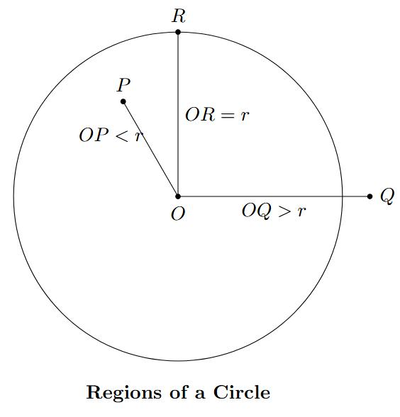
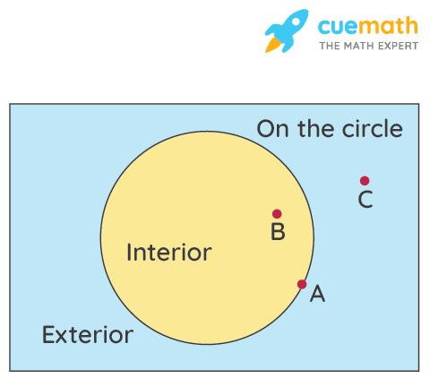
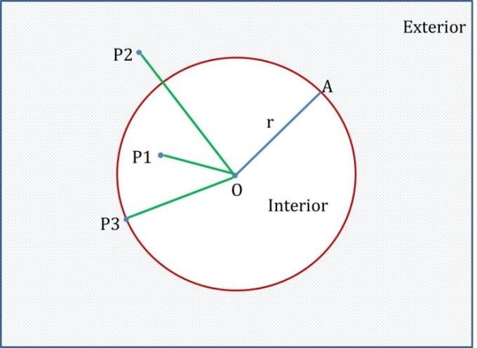

Simple Definition
# Source: AI Source: Provided by: [Data Path: Persons Table -> ID Column: 1, Name_En Column: Motasem Essam] -> From: [ChatGPT] on [7/25/2026]
The locus of points inside a circle is the region whose points are closer to the center than the radius; the locus of points outside a circle is the region whose points are farther from the center than the radius.
Thus:
$$\boxed{\text{Inside: }OP<r} \\ \boxed{\text{Outside: }OP>r}$$
The boundary between these two regions is the circle itself:
$$\boxed{\text{Boundary: }OP=r}$$

Fundamental Concept
# Source: AI Source: Provided by: [Data Path: Persons Table -> ID Column: 1, Name_En Column: Motasem Essam] -> From: [ChatGPT] on [7/25/2026]
Suppose $C$is a fixed circle with center $O$and radius $r$.
The distance $OP$determines the location of $P$.
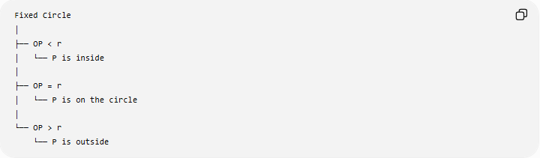
Fixed Circle
│
├── OP < r
│ └── P is inside
│
├── OP = r
│ └── P is on the circle
│
└── OP > r
└── P is outside
Therefore:
$$\boxed{OP<r, OP=r, OP>r}$$
are the three fundamental positional relationships.

Locus of Points Inside a Circle
# Source: AI Source: Provided by: [Data Path: Persons Table -> ID Column: 1, Name_En Column: Motasem Essam] -> From: [ChatGPT] on [7/25/2026]
The locus of points inside a circle is the set of all points $P$satisfying
$$\boxed{OP<r}.$$
These points are strictly closer to the center than the circle's radius.
This region is the interior of the circle.
For example, if
$$r=5,$$
then every point satisfying
$$OP<5$$
is inside the circle.

Example 1 — Inside a Circle
# Source: AI Source: Provided by: [Data Path: Persons Table -> ID Column: 1, Name_En Column: Motasem Essam] -> From: [ChatGPT] on [7/25/2026]
Suppose the circle has center
$$O=\left(0 , 0\right)$$
and radius
$$r=5.$$
Consider
$$P=\left(3 , 2\right).$$
Then:
$$OP=\sqrt{3^{2}+2^{2}} \\ =\sqrt{13}.$$
Since
$$\sqrt{13}<5,$$
we have
$$\boxed{OP<r}.$$
Therefore, $P$is inside the circle.

Coordinate Locus of the Interior
# Source: AI Source: Provided by: [Data Path: Persons Table -> ID Column: 1, Name_En Column: Motasem Essam] -> From: [ChatGPT] on [7/25/2026]
For a circle centered at
$$O=\left(h , k\right)$$
with radius $r$, the circle itself is:
$${\left(x-h\right)}^{2}+{\left(y-k\right)}^{2}=r^{2}.$$
The interior is:
$$\boxed{{\left(x-h\right)}^{2}+{\left(y-k\right)}^{2}<r^{2}}$$
This inequality describes all points strictly inside the circle.
For a circle centered at the origin:
$$\boxed{x^{2}+y^{2}<r^{2}}.$$
For example:
$$x^{2}+y^{2}<25$$
represents all points inside a circle of radius $5$.
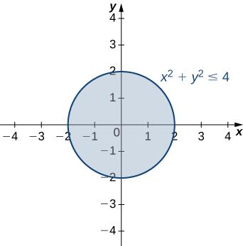
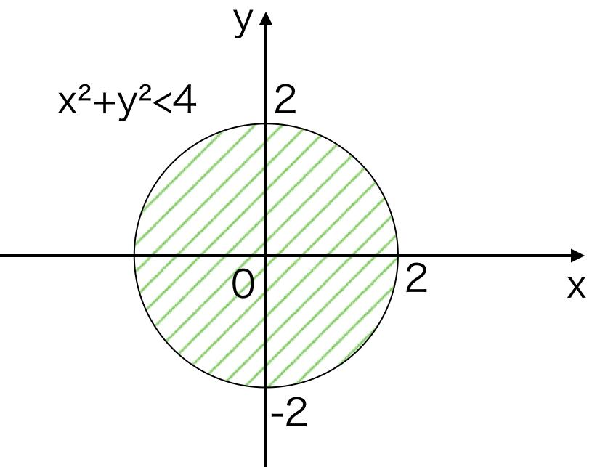
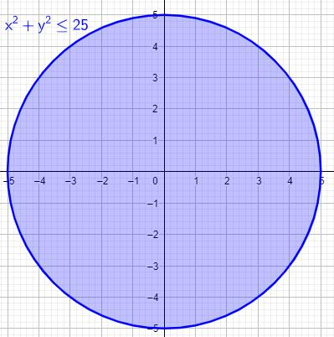

Locus of Points Outside a Circle
# Source: AI Source: Provided by: [Data Path: Persons Table -> ID Column: 1, Name_En Column: Motasem Essam] -> From: [ChatGPT] on [7/25/2026]
The locus of points outside a circle is the set of all points $P$satisfying
$$\boxed{OP>r}.$$
These points are farther from the center than the radius.
For example, if
$$r=5,$$
then every point satisfying
$$OP>5$$
is outside the circle.

Example 2 — Outside a Circle
# Source: AI Source: Provided by: [Data Path: Persons Table -> ID Column: 1, Name_En Column: Motasem Essam] -> From: [ChatGPT] on [7/25/2026]
Suppose:
$$O=\left(0 , 0\right), r=5.$$
Take
$$P=\left(6 , 0\right).$$
Then:
$$OP=6.$$
Since
$$6>5,$$
we have
$$\boxed{OP>r}.$$
Therefore, $P$is outside the circle.

Coordinate Locus of the Exterior
# Source: AI Source: Provided by: [Data Path: Persons Table -> ID Column: 1, Name_En Column: Motasem Essam] -> From: [ChatGPT] on [7/25/2026]
For a circle centered at
$$O=\left(h , k\right)$$
with radius $r$, the exterior is:
$$\boxed{{\left(x-h\right)}^{2}+{\left(y-k\right)}^{2}>r^{2}}.$$
For a circle centered at the origin:
$$\boxed{x^{2}+y^{2}>r^{2}}.$$
For example:
$$\boxed{x^{2}+y^{2}>25}$$
represents all points outside the circle of radius $5$.

Points on the Circle — The Boundary
# Source: AI Source: Provided by: [Data Path: Persons Table -> ID Column: 1, Name_En Column: Motasem Essam] -> From: [ChatGPT] on [7/25/2026]
Although the topic concerns points inside or outside the circle, the boundary is important because it separates the two regions.
Points on the circle satisfy:
$$\boxed{OP=r}.$$
In coordinates:
$$\boxed{{\left(x-h\right)}^{2}+{\left(y-k\right)}^{2}=r^{2}}.$$
Thus:
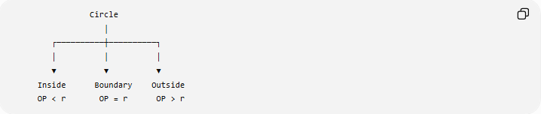
Circle
│
┌──────────┼──────────┐
│ │ │
▼ ▼ ▼
Inside Boundary Outside
OP < r OP = r OP > r

Open Disk
# Source: AI Source: Provided by: [Data Path: Persons Table -> ID Column: 1, Name_En Column: Motasem Essam] -> From: [ChatGPT] on [7/25/2026]
The set
$$\boxed{OP<r}$$
is called the open disk centered at $O$with radius $r$.
It contains:
- every point strictly inside the circle
- but not the boundary circle.
In coordinates:
$$\boxed{{\left(x-h\right)}^{2}+{\left(y-k\right)}^{2}<r^{2}}.$$
The word open indicates that the boundary is excluded.

Closed Disk
# Source: AI Source: Provided by: [Data Path: Persons Table -> ID Column: 1, Name_En Column: Motasem Essam] -> From: [ChatGPT] on [7/25/2026]
If the boundary is included, the condition becomes:
$$\boxed{OP≤r}.$$
This is the closed disk.
It consists of:
- all points inside the circle
- all points on the circle.
In coordinates:
$$\boxed{{\left(x-h\right)}^{2}+{\left(y-k\right)}^{2}≤r^{2}}.$$
Therefore:
$$\boxed{\text{Closed Disk}=\text{Interior}+\text{Boundary}}$$

Exterior Including the Boundary
# Source: AI Source: Provided by: [Data Path: Persons Table -> ID Column: 1, Name_En Column: Motasem Essam] -> From: [ChatGPT] on [7/25/2026]
Similarly,
$$\boxed{OP≥r}$$
represents all points that are:
- outside the circle, or
- on the circle.
In coordinates:
$$\boxed{{\left(x-h\right)}^{2}+{\left(y-k\right)}^{2}≥r^{2}}.$$
This is the closed exterior of the circle.

Complete Classification
# Source: AI Source: Provided by: [Data Path: Persons Table -> ID Column: 1, Name_En Column: Motasem Essam] -> From: [ChatGPT] on [7/25/2026]
For a fixed circle with center $O$and radius $r$:
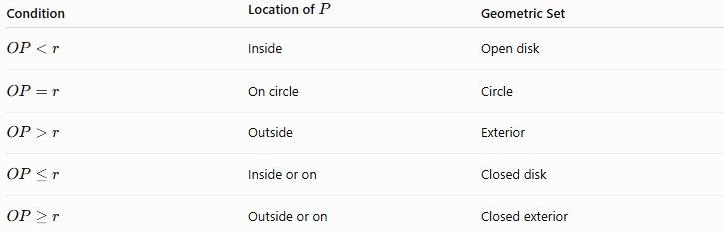
Condition | Location of $P$ | Geometric Set
$$OP<r$$ | Inside | Open disk
$$OP=r$$ | On circle | Circle
$$OP>r$$ | Outside | Exterior
$$OP≤r$$ | Inside or on | Closed disk
$$OP≥r$$ | Outside or on | Closed exterior
The complete classification is:
$$\boxed{\begin{matrix}OP<r & ⇒ & \text{Inside} \\ OP=r & ⇒ & \text{On} \\ OP>r & ⇒ & \text{Outside}\end{matrix}}$$

Example 3 — Classifying Several Points
# Source: AI Source: Provided by: [Data Path: Persons Table -> ID Column: 1, Name_En Column: Motasem Essam] -> From: [ChatGPT] on [7/25/2026]
Consider the circle
$$x^{2}+y^{2}=25.$$
Its center is
$$O=\left(0 , 0\right)$$
and radius is
$$r=5.$$
Consider the following points:
Point A
$$A=\left(3 , 4\right) \\ OA=\sqrt{3^{2}+4^{2}}=5.$$
Therefore:
$$\boxed{A\text{ is on the circle}}$$
Point B
$$B=\left(2 , 1\right) \\ OB=\sqrt{2^{2}+1^{2}}=\sqrt{5}<5.$$
Therefore:
$$\boxed{B\text{ is inside}}$$
Point C
$$C=\left(6 , 2\right) \\ OC=\sqrt{6^{2}+2^{2}}=\sqrt{40}>5.$$
Therefore:
$$\boxed{C\text{ is outside}}$$

Geometric Interpretation
# Source: AI Source: Provided by: [Data Path: Persons Table -> ID Column: 1, Name_En Column: Motasem Essam] -> From: [ChatGPT] on [7/25/2026]
The circle divides the plane into two main regions:
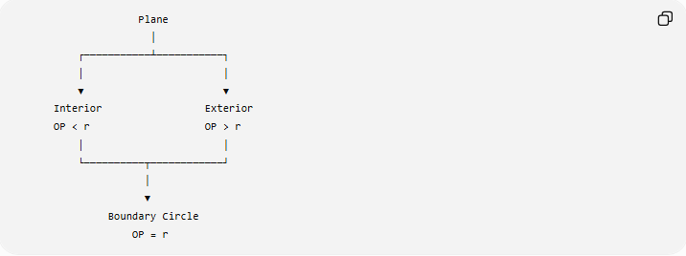
Plane
│
┌───────────┴───────────┐
│ │
▼ ▼
Interior Exterior
OP < r OP > r
│ │
└──────────┬────────────┘
│
▼
Boundary Circle
OP = r
The circle itself acts as the boundary separating the inside from the outside.

Example 4 — Circle Not Centered at the Origin
# Source: AI Source: Provided by: [Data Path: Persons Table -> ID Column: 1, Name_En Column: Motasem Essam] -> From: [ChatGPT] on [7/25/2026]
Consider:
$${\left(x-2\right)}^{2}+{\left(y-3\right)}^{2}=16.$$
Therefore:
$$O=\left(2 , 3\right), r=4.$$
The inside locus is:
$$\boxed{{\left(x-2\right)}^{2}+{\left(y-3\right)}^{2}<16}.$$
The boundary is:
$$\boxed{{\left(x-2\right)}^{2}+{\left(y-3\right)}^{2}=16}.$$
The outside locus is:
$$\boxed{{\left(x-2\right)}^{2}+{\left(y-3\right)}^{2}>16}.$$
So the three regions are:
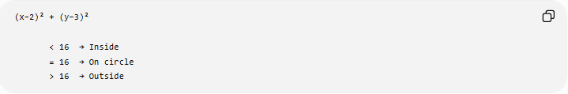
(x−2)² + (y−3)²

< 16 → Inside
= 16 → On circle
> 16 → Outside

Relationship to Fixed-Distance Loci
# Source: AI Source: Provided by: [Data Path: Persons Table -> ID Column: 1, Name_En Column: Motasem Essam] -> From: [ChatGPT] on [7/25/2026]
This topic is closely related to the locus of points at a fixed distance from a point.
For a fixed center $O$:
$$OP=r$$
produces the circle.
But changing the equality to inequalities produces regions:
$$OP<r$$
produces the interior, while
$$OP>r$$
produces the exterior.
Therefore:
$$\boxed{\begin{aligned}OP=r&→\text{Circle} \\ OP<r&→\text{Interior} \\ OP>r&→\text{Exterior}\end{aligned}}$$

Relationship to Circle Locus
# Source: AI Source: Provided by: [Data Path: Persons Table -> ID Column: 1, Name_En Column: Motasem Essam] -> From: [ChatGPT] on [7/25/2026]
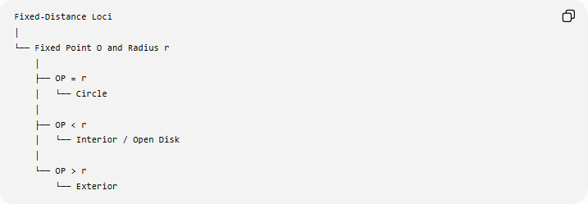
Fixed-Distance Loci
│
└── Fixed Point O and Radius r
│
├── OP = r
│ └── Circle
│
├── OP < r
│ └── Interior / Open Disk
│
└── OP > r
└── Exterior
Thus, the circle is the boundary locus, while the inequalities describe the regions on either side of the boundary.

One-Sided Interpretation
# Source: AI Source: Provided by: [Data Path: Persons Table -> ID Column: 1, Name_En Column: Motasem Essam] -> From: [ChatGPT] on [7/25/2026]
If a problem says:
Find the locus of points within a distance $r$of $O$.
the condition is:
$$\boxed{OP≤r}.$$
This gives the closed disk.
If it says:
Find the locus of points less than $r$units from $O$.
then:
$$\boxed{OP<r}.$$
This gives the open disk.
If it says:
Find the locus of points at least $r$units from $O$.
then:
$$\boxed{OP≥r}.$$
This gives the exterior including the boundary.

Circle, Interior, and Exterior
# Source: AI Source: Provided by: [Data Path: Persons Table -> ID Column: 1, Name_En Column: Motasem Essam] -> From: [ChatGPT] on [7/25/2026]
It is important not to confuse these three geometric sets:
Circle
$$\boxed{OP=r}$$
Only the boundary.
Interior
$$\boxed{OP<r}$$
Only the points strictly inside.
Disk
$$\boxed{OP≤r}$$
Interior plus boundary.
Exterior
$$\boxed{OP>r}$$
Only the points strictly outside.

Important Terminology
# Source: AI Source: Provided by: [Data Path: Persons Table -> ID Column: 1, Name_En Column: Motasem Essam] -> From: [ChatGPT] on [7/25/2026]
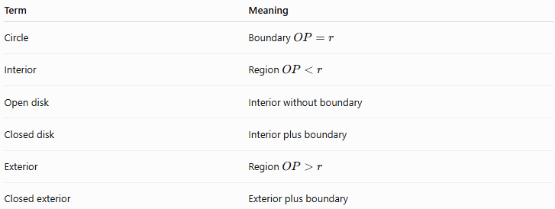
Term | Meaning
Circle | Boundary $OP=r$
Interior | Region $OP<r$
Open disk | Interior without boundary
Closed disk | Interior plus boundary
Exterior | Region $OP>r$
Closed exterior | Exterior plus boundary
A particularly important distinction is:
$$\boxed{\text{Circle}≠\text{Disk}}$$
A circle is the boundary, whereas a disk is the region bounded by the circle.

Classification Within Types of Loci
# Source: AI Source: Provided by: [Data Path: Persons Table -> ID Column: 1, Name_En Column: Motasem Essam] -> From: [ChatGPT] on [7/25/2026]
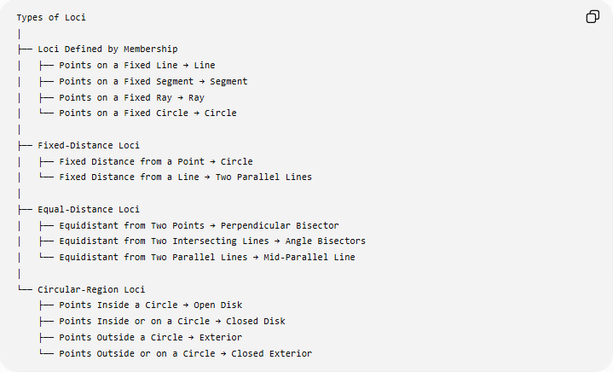
Types of Loci
│
├── Loci Defined by Membership
│ ├── Points on a Fixed Line → Line
│ ├── Points on a Fixed Segment → Segment
│ ├── Points on a Fixed Ray → Ray
│ └── Points on a Fixed Circle → Circle
│
├── Fixed-Distance Loci
│ ├── Fixed Distance from a Point → Circle
│ └── Fixed Distance from a Line → Two Parallel Lines
│
├── Equal-Distance Loci
│ ├── Equidistant from Two Points → Perpendicular Bisector
│ ├── Equidistant from Two Intersecting Lines → Angle Bisectors
│ └── Equidistant from Two Parallel Lines → Mid-Parallel Line
│
└── Circular-Region Loci
├── Points Inside a Circle → Open Disk
├── Points Inside or on a Circle → Closed Disk
├── Points Outside a Circle → Exterior
└── Points Outside or on a Circle → Closed Exterior
The last group is a descriptive/practical classification of locus regions rather than a universally standardized formal taxonomy.

Key Formulas
# Source: AI Source: Provided by: [Data Path: Persons Table -> ID Column: 1, Name_En Column: Motasem Essam] -> From: [ChatGPT] on [7/25/2026]
For a circle centered at $O=\left(h , k\right)$with radius $r$:
Boundary
$$\boxed{{\left(x-h\right)}^{2}+{\left(y-k\right)}^{2}=r^{2}}$$
Interior
$$\boxed{{\left(x-h\right)}^{2}+{\left(y-k\right)}^{2}<r^{2}}$$
Closed Disk
$$\boxed{{\left(x-h\right)}^{2}+{\left(y-k\right)}^{2}≤r^{2}}$$
Exterior
$$\boxed{{\left(x-h\right)}^{2}+{\left(y-k\right)}^{2}>r^{2}}$$
Closed Exterior
$$\boxed{{\left(x-h\right)}^{2}+{\left(y-k\right)}^{2}≥r^{2}}$$

Key Points
# Source: AI Source: Provided by: [Data Path: Persons Table -> ID Column: 1, Name_En Column: Motasem Essam] -> From: [ChatGPT] on [7/25/2026]
- $OP<r$means the point is inside the circle.
- $OP=r$means the point is on the circle.
- $OP>r$means the point is outside the circle.
- The circle is the boundary separating the two regions.
- $OP<r$gives an open disk.
- $OP≤r$gives a closed disk.
- $OP>r$gives the exterior.
- $OP≥r$gives the closed exterior.
- In coordinates, compare
$${\left(x-h\right)}^{2}+{\left(y-k\right)}^{2}$$
with $r^{2}$.
- The inequalities describe regions rather than only a one-dimensional boundary.

Conclusion
# Source: AI Source: Provided by: [Data Path: Persons Table -> ID Column: 1, Name_En Column: Motasem Essam] -> From: [ChatGPT] on [7/25/2026]
The locus of points inside or outside a circle is determined by comparing the distance from a variable point $P$to the fixed center $O$with the fixed radius $r$:
$$\boxed{\begin{matrix}OP<r & → & \text{Inside} \\ OP=r & → & \text{On the circle} \\ OP>r & → & \text{Outside}\end{matrix}}$$
Thus, a circle provides the boundary, while the corresponding inequalities describe the regions on either side of that boundary.

